EXPERIMENT NO: 02
AIM OF THE EXPERIMENT: Determine the strength of given sodium hydroxide solution by titrating against standard oxalic acid solution using phenolphthalein indicator.
APPARATUS REQUIRED:
- Beaker (250mL and 100mL)
- Conical flask (100mL)
- Burette (50mL)
- Burette stand
- Pipette (10mL)

CHEMICAL REQUIRED:
- Oxalic acid
- Sodium hydroxide
- Phenolphthalein

THEORY:
Acid base titration Acid base titrations are based on the principles of acidimetry and alkalimetry. The chemical reaction involved in acid-base titration is known as neutralization reaction. It involves the combination of H3O+ ions with OH– ions to form water. In acid-base titrations, solutions of alkali are titrated against standard acid solutions. The estimation of an alkali solution using a standard acid solution is called acidimetry. Similarly, the estimation of an acid solution using a standard alkali solution is called alkalimetry.
Titration:
The standard solution is usually added from a graduated vessel called a burette. The process of adding standard solution until the reaction is just complete is termed as titration and the substance to be determined is said to be titrated.
Indicator:
It is a chemical reagent used to recognize the attainment of end point in a titration. After the reaction between the substance and the standard solution is complete, the indicator should give a clear colour change.
End point and Equivalent point :
For a reaction, a stage which shows the completion of a particular reaction is known as end point. Equivalence point is a stage in which the amount of reagent added is exactly and stoichiometrically equivalent to the amount of the reacting substance in the titrated solution. The end point is detected by some physical change produced by the solution, by itself or more usually by the addition of an auxiliary reagent known as an ‘indicator’. The end point and the equivalence point may not be identical. End point is usually detected only after adding a slight excess of the titrant. In many cases, the difference between these two will fall within the experimental error. The reaction applicable in this practical is
COOH + 2NaOH ---------- 2 COONa + 2H2O
COOH
Oxalic Acid Sodium Hydroxide Sodium Oxalate Water
PROCEDURE:
1. Prepare 0.1 N NaOH solution (40g of NaOH dissolved in 1000mL distilled water to form 1M NaOH solution 4.0 g of NaOH dissolved in 1000mL distilled water to form 0.1M NaOH solution .
2. Rinse and fill given sodium hydroxide in clean burette upto zero mark.
3. Pipette out 20mL of oxalic acid and transfer it into the conical flask
4. Add 2-3 drops of phenolphthalein indicator into the conical flask.
5. Add dropwise NaOH from burette into the conical flask and stir the mixture.
6. Repeat the step (4) until colour changes from colourless to permanent light pink. i.e. at the endpoint of titration.
7. After the formation of permanent light pink colour stop the addition and record the burette reading.
8. Repeat procedure for three consecutive readings.
Observation Table:
Burette Reading | Pilot Reading | 1 | 2 | 3 | Volume of base(VB)=Mean difference=(1+2+3)/3
Initial Burette Reading (IBR)
Final Burette
Reading (FBR)
Difference
(FBR-IBR)

Calculations:
Molarity of NaOH
NaOH vs Oxalic Acid
Molarity of Base (MB) x Volume of Base(VB) = Molarity of Acid(MA) x Volume of Acid (VA)
Molarity of NaOH = MB= ....M_{A} x V_{A}/V_{B}=..0.1 x 20/V_{B}=................ M
Strength of NaOH = Molarity of NaOH× Equivalent Weight of NaOH
= ................... × 40 g/L = ................... g/L
RESULTS AND/OR INTERPRETATION
1. Molarity of NaOH = .................M
2. Strength of NaOH = ................g/L
CONCLUSIONS AND/OR VALIDATION
............. amount of NaOH dissolve for the preparation of ...................... M solution
ASSIGNMENT QUESTIONS:
- What is Molarity ?
- What is Normality ?
- Define Standardization ?
- What is Indicator ? Give one Example
- What do you mean by end point of reaction?
- What is Neutralization reaction?
- What happened when oxalic acid reacts with sodium hydroxide ? write its chemical reaction
- What is the colour of Phenophthalein indicator ?
- Calculate the molecular mass of Oxalic Acid?
- Write chemicals and apparatus used in titration ?

EXPERIMENT NO :1
AIM OF THE EXPERIMENT: Prepare the standard solution of oxalic acid and potassium permanganate.
APPARATUS REQUIRED:
- Watch glass
- Standard volumetric flask (250 mL)
- Funnel
- Beakers

CHEMICAL REQUIRED:
- Oxalic acid
- Potassium Permanganate
THEORY: NORMAL SOLUTION:
The normal solution is prepared by dissolving 1 g equivalent weight of solute, making 1000mL
of solution Preparation of Normal Solution of Oxalic acid
Molecular weight of oxalic acid = 126.
Equivalent weight = Molecular weight /Basicity No =
126/2 = 63 (Valency of oxalic acid=2)

1g equivalent weight of oxalic acid dissolved in 1000 mL distilled water, form 1N solution 63g of Oxalic Acid dissolved in 1000 mL distilled water, form, 1N Oxalic acid solution.
0.63g of Oxalic acid dissolved in 1000mL distilled water, form, 0.01 N Oxalic acid solution Preparation of 0.01N KMnO4 solution.
Equivalent weight = Molecular weight Valency (Basicity No) =
158/5 = 31.6g (Valency of KMnO4 = 5) 31.6 g of KMnO4 dissolved in 1000mL distilled water to form 1 N KMnO4 solution 0.316 g KMnO4 dissolved in 1000 mL distilled water to form 0.01 N KMnO4 solution.

MOLAR SOLUTION:
Number of moles of solute dissolved in 1000mL water,
Forms molar solution [For molar solution refer - Unit 1, section 1.3 Preparation of 0.02 M Oxalic Acid Solution Molecular formula of oxalic acid –(C2H6O6) Molecular weight = [ (2×12)+(6×1)+(6×16)]=[24 + 6 + 96]=126g/mol
Weight of Oxalic Acid = Molarity × Molecular Mass of Oxalic acid×Volume
=150 × 126 × 100/ 1000 Weight of oxalic acid = 0.252 g For the preparation of 0.02 M oxalic acid solution, 0.252 g of oxalic acid is dissolved in 100mL water.
Preparation of Molar solution of Potassium Permanganate (KMNO4) Preparation of 0.02 M KMnO4 solution

Molecular weight of KMnO4 = [39+55+(16 × 4)] =158

Weight of KMnO4 = Molarity × Molecular Weight of KMnO4 × Volume
= 150 × 158 × 100 /1000 = 0.316g

For Preparation of 0.02 M KMnO4 Solution, 0.316g KMnO is dissolved in 100
PROCEDURE:
Part-A Preparation of Oxalic Acid Solution
1. Clean the watch glass and weigh 0.252 g of oxalic acid, and transfer it into a standard volumetric flask and add distilled water up to 100mL mark.
2. Toggle the solution 3-4 times so that we can get a homogenous mixture of oxalic acid.
Part-B Preparation of KMnO4 Solution
1. Clean the watch glass and weigh out 0.316 g of a gram of KMnO4 and transfer it into a standard volumetric flask and add distilled water up to 100mL mark.
2. Toggle the solution 3-4 times so that we can get a homogenous mixture of KMnO4
RESULT
.........g of oxalic acid is used for the preparation of..............solution.
ASSIGNMENT QUESTION:
1.What is solution?
2.Define molarity of solution?
3.write chemical formula of oxalic acid ?
4. write chemical formula of Potassium Permanganate
5. Calculate the molecular mass and equivalent weight of Oxalic Acid?
6. Calculate the molecular mass and equivalent weight of potassium permanganate?
7. What is normality of solution?
8. what is standard solution?
9. What is Basicity ? Give examples
10. Calculate molecular mass and equivalent weight of sodium hydroxide ?

EXPERIMENT NO:3
AIM OF THE EXPERIMENT: Estimate the total hardness of given water sample using standard ethylene diamine tetra acetic acid (EDTA) solution.
APPARATUS REQUIRED:
- Conical flask(100 ml)
- Burette(50 ml)
- pipette(10 ml)
- beaker (100 ml)
- Volumetric flask(250ml)

CHEMICAL REQUIRED:
- Water sample
- EDTA (0.1M)
- Buffer solution (pH=10)
- Eriochrome Black T(EBT) indicator

THEORY:
The estimation of hardness is based on complexometric titration. Hardness of water is determined by titrating with a standard solution of ethylene diamine tetra acetic acid (EDTA) which is a complexing agent. Since EDTA is insoluble in water, the disodium salt of EDTA was taken for this experiment.

PROCEDURE:
Part A: Total Hardness of water
1. Rinse and fill the burette with 0.01M EDTA solution.
2. Pipette out 10ml of water sample in conical flask.
3. Add 5ml of buffer solution(pH=10) and 2-3 drops of EBT indicator in the conical flask.
4. Due to addition of EBT, mixture in conical flask shows wine red colouration.
5. Titrate the solution in conical flask with EDTA till colour changes from wine red to light blue.
6. Repeat the procedure for three consequent burette reading.
Part B: Permanent Hardness of Water
1. Boil the given sample for 8-10 minutes and filter.
2. Pipette out 10 mL of filtered water in conical flask.
3. Add 5ml of buffer solution(pH=10) and 2-3 drops of EBT indicator in the conical flask.
4. Due to addition of EBT, mixture in conical flask shows wine red colouration.
5. Titrate the solution in conical flask with EDTA till colour changes from wine red
to light blue.

TABULATION A (Total Hardness of Water)

Readings | Pilot Reading | 1 | 2 | 3 | TH=Mean  Difference  =(1+2+3)/3
Initial Burette Reading (IBR)
Final Burette Reading (FBR)
Difference (FBR-IBR)
TABULATION B (Permanent Hardness of Water)
Readings | Pilot Reading | 1 | 2 | 3 | PH = Mean  Difference  =(1+2+3)/3
Initial Burette Reading (IBR)
Final Burette Reading (FBR)
Difference (FBR-IBR)
CALCULATION:
Part A : Total Hardness of water
Step 1 :
1000mL of 1M EDTA 100 g CaCO3
(TH) mL of 0.01M EDTA 100 x 0.01 x TH /1000 g of CaCO3 = 0.001 × TH g of CaCO3
0.001 × TH =0.001×...................=..................(y)g of CaCO3
Step 2:
10ml of water sample contains (y) g of CaCO3
1000ml of water sample contains =100×(y)g of CaCO3 =.............g of CaCO3
Conversion of g to mg
1000mL of water sample contains = 100×(y) g of CaCO3 ×1000 mg of CaCO3
1000mL of water sample contains =......................... mg of CaCO3
Part B: Permanent Hardness (PH) of Water:Step 1 : 1000mL of 1M EDTA 100 g CaCO3 (PH) mL of 0.01M EDTA 100 × 0.01 × PH 1000 g of CaCO3= 0.001 × PH g of CaCO3

0.001 ×PH =0.001×...................=..................(z)g of CaCO3
Step 2 :
10 mL of water sample contains (z) g of CaCO3
1000 mL of water sample contains = 100 × (z)g of CaCO3 =.............g of CaCO3
Conversion of g to mg
1000 mL of water sample contains = 100×( z ) g of CaCO3 ×1000mg of CaCO3

1000 mL of water sample contains =.........................mg of CaCO3 ---- (II)
Temporary hardness = Total Hardness - permanent hardness of water in mg of CaCO3
= I – II = ........... = ......................... mg of CaCO3
RESULTS AND/OR INTERPRETATION:
1. Total Hardness for given sample of water is = .....................ppm of CaCO3 equivalent

2. Permanent Hardness for given sample of water is =............... ppm of CaCO3 equivalent

3. Temporary Hardness for given sample of water is =............... ppm of CaCO3 equivalent
CONCLUSIONS AND/OR VALIDATION
ASSIGNMENT QUESTION:
1.What is EDTA? Write its Valency
2.What is EBT? Write its use
3.which chemicals responsible for hardness of water?
4.What is full form of ppm?
5.Calculate equivalent weight of CaCO₃?
6.Write two uses of EDTA?
7.Define Hardness of water ? write its type
8.Write two chemicals and apparatus used in this experiment?
9.What is the colour of EBT?
10.Which colour formed at the end point of EDTA titration?

EXPERIMENT NO :4
AIM OF THE EXPERIMENT: Determine the alkalinity of a given water sample using 0.01M sulphuric acid.

APPARATUS REQUIRED:
- Burette
- Pipette
- conical flask (50mL)
- Volumetric flask (250ml)
- Measuring
- standard flask

CHEMICAL REQUIRED:
- Standard sulphuric acid
- Phenolphthalein indicator
- Methyl orange
- ethyl alcohol
- Distilled water

THEORY:
The alkalinity of the water is a measure of its capacity to neutralize acids. The alkalinity of natural waters is due primarily to the salts of week acids. Bicarbonates represent the major form of alkalinity. Alkalinity can be expressed as follows: Alkalinity (mol/L) = [HCO3 ⁻ ] + 2 [CO3 ²⁻ ] + [OH⁻ ] – [H⁺ ] Alkalinity is significant in many uses and treatments of natural waters and wastewaters. As alkalinity of many surface waters constitute of carbonates, bicarbonate and hydroxide contents, it is assumed to be an indicator of these constituents as well.

PROCEDURE:

Preparation of 0.01 N Sulphuric acid Solution
1. Take approximately 500ml distilled water in a 1000 mL standard flask.
2. Measure 200mL of 0.1N sulphuric acid and add slowly along the side of the standard flask.
3. Then dilute up to 1000ml using distilled water hence we get 0.02N sulphuric acid.
Preparation of Phenolphthalein Indicator
1. Weight out 1g of phenolphthalein powder and add 100 mL of ethyl alcohol or water.
2. Use a ready-made phenolphthalein indicator.
Titration Procedure
i. Rinse and fill the 0.01N sulphuric acid into the burette.
ii. Measure exactly 100mL of sample and transfer it into 250mL conical flask.
iii. Add few drops of phenolphthalein indicator into the conical flask which shows pink colouration which indicates the presence of alkalinity due to hydroxyl ions.
iv. Titrate this against 0.01 N Sulphuric acid till the pink colour disappears which shows neutralization of hydroxyl ions. Record this burette reading which is accountable for phenolphthalein alkalinity.
v. To the same colourless solution in the conical flask add few drops of methyl orange indicator. The colour of the solution changes to yellow which is due to the presence of
CO3 ^{2–} and HCO3 – ions in the water sample.

vi. Continue the titration from the point where stopped for the phenolphthalein alkalinity.
vii. Titrate till the solution becomes reddish orange.
viii.The entire volume V2 of sulphuric acid is noted down and it is accountable for calculating methyl orange alkalinity.
ix. Repeat the procedure for consecutive readings.

Observation Table 1: Phenolphthalein alkalinity:
Readings | Pilot Reading | 1 | 2 | 3 | P=Mean  Difference  =(1+2+3)/3
Initial Burette Reading (IBR)
Final Burette Reading (FBR)
Difference (FBR-IBR)

Observation Table 1: Total alkalinity:
Readings | Pilot Reading | 1 | 2 | 3 | M=Mean  Difference  =(1+2+3)/3
Initial Burette Reading (IBR)
Final Burette Reading (FBR)
Difference (FBR-IBR)

Calculations
For alkalinity
(i) Alkalinity due to OH– (if P=M)
Step 1 :
1000 mL of 1N H2SO4= 17 g OH–
=17 × 0.01 × M / 1000 g of OH– = 17 × 0.01 / 1000 =......(x)g of OH–

Step 2 :
100 mL of water sample contains =(x) g =......................... g of OH–
1000 mL of water sample contains =(x)×10 =......................... g of OH–
1000 mL water sample contains = (x) ×10×1000 = ........................ mg of OH–
1000 mL water sample contains =......................... mg of OH–
(ii) Alkalinity due to CO3 ^{2–}
( if p<(1 )/2M)

Step 1:
1000 mL of 1N H2SO4 = 30g CO3 ^{2–}
[2P-M] mL of 0.01N H2SO4 = 30 × 0.01 × [2P–M]/ 1000 g of CO3 ^{2–}

= 30 × 0.01 / 1000 = ........................ (y)g of CO3 ^{2–}

Step 2 :
100mL of water sample contains =(y) g = ......................... g of CO3 ^{2–}
1000mL of water sample contains =(y)×10 = ......................... g of CO3 ^{2–}
1000mL water sample contains = (y) ×10×1000 = ......................... mg of CO3 ^{2–}
1000mL water sample contains = .......................... mg of CO3 ^{2–}

(iii) Alkalinity due to HCO3 – ( if p <1/ 2M )

Step 1 : 1000 mL of 1N H2SO4 = 61g HCO3 – [2P-M] mL of 0.01N H2SO4= 61 × 0.01 × [2P – M] / 1000 g of HCO3 – = 61 × 0.01 × ./ 1000 =...............(z)g of HCO3 –

Step 2 :
100 mL of water sample contains =(z) g =............................ g of HCO3 –
1000 mL of water sample contains =(z)×10 =............................ g of HCO3 –
1000 mL water sample contains= (z) ×10×1000 = .......................... mg of HCO3 –
1000 mL water sample contains =........................... mg of HCO3 –
^{RESULTS}
1. Alkalinity due to OH – =............................. mg/L

2. Alkalinity due to CO3 ^{2–} =............................ mg/L

3. Alkalinity due to HCO3 – =............................ mg/L
CONCLUSIONS AND/OR VALIDATION
ASSIGNMENT QUESTION
1.What is alkalinity of water?
2.Write the formula of carbonate and bicarbonate ion?
3.Write chemical required for this experiment?
4. Write apparatus required for this experiment?
5.what happened when methyl orange indicator added to the solution?
6. what happened when phenolphthalein indicator added to the solution?

EXPERIMENT NO :5
AIM OF THE EXPERIMENT: Determine the percentage of iron in haematite ore by standard KMnO₄ solution.

APPARATUS REQUIRED:
- Burette (50 ml)
- pipette (10 ml)
- round bottom flask (250 ml)
- wire gauze
- conical flask (100 ml)
- Volumetric flask (250 ml)

CHEMICAL REQUIRED:
- KMnO₄ (Potassium permanganate)
- dilute H₂SO₄
- zinc granules
- sample ore material
- oxalic acid
- HCl

THEORY:
Haematite is an important ore of iron. For determination of iron in the given ore sample, the ore sample is dissolved in dilute HCl or dilute H₂SO₄. Iron is converted to ferric or ferrous salt solution with liberation of hydrogen gas. Reducing agents used for converting Fe3+ to Fe2+ are metallic zinc or stannous chloride. The Fe2+ present in the solution can be determined by titrating with standard KMnO₄ solution.
MnO₄– + 8H+ + Fe2+ Mn2+ + Fe3+ + 4H₂O

PROCEDURE: Part- A Preparation of Sample Solution
- Weight 1 g of ore and transfer it into 250 ml round bottom flask.
- Add 100 ml of dilute H₂SO₄ into the round bottom flask and gently heat on wire gauze till the sample dissolve completely.
- Add few granules of zinc when sample dissolves.
- Cool it and transfer in to 250 ml volumetric flask, dilute the solution up to mark using distilled water.

Part- B Standardization of KMnO₄
- Prepare 0.1 N KMnO₄ [refer preparation of normal solution,
- Pipette out 10 ml of 0.1N oxalic acid in conical flask.
- Add 10 ml of dilute H₂SO₄ and heat the solution up to 70°C
- Titrate the above solution against standard KMnO₄ solution till light pink colour appears
- Repeat the procedure for three consecutive readings.

Part- C Determination of Percentage of Iron
- Rinse and fill the burette with standard KMnO₄ solution.
- Pipette out 10 ml of sample solution in conical flask. Add 10 ml of dilute H₂SO₄ solution
- Titrate the above solution against standard KMnO₄ solution till light pink colour appears
- Repeat the procedure for three consecutive reading.

OBSERVATIONS AND CALCULATIONS

Standardization of KMnO₄ |  |  | Determination of % of Iron
Sr.no | Observation | Reading | Sr.no | Observation | Reading
1 | The solution in burette |  | 1 | The solution in burette
2 | Solution by pipette |  | 2 | Solution by pipette
3 | Indicator used |  | 3 | Indicator used
4 | Endpoint |  | 4 | Endpoint

Table 1: Standardization of KMnO₄

Readings | Pilot Reading | 1 | 2 | 3 | V2=Mean Difference  =(1+2+3)/3
Initial Burette Reading (IBR)
Final Burette Reading (FBR)
Difference (FBR-IBR)
Calculation Table 2: Determination of Percentage of Iron

Readings | Pilot Reading | 1 | 2 | 3 | V3=Mean Difference  =(1+2+3)/3
Initial Burette Reading
Final Burette Reading
Difference (FBR-IBR)

Calculation

Standardization of KMnO₄
N₁V₁= N₂V₂
N₁= Normality of oxalic acid 0.1N V₁= Volume of oxalic acid 10mL N₂= Normality of KMnO₄ V₂= Volume of KMnO₄ from table 1
N₂= 
=  = 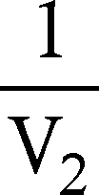 = …………. = ………….

Determination of Percentage of Iron
Step 1 1000mL 1N KMnO₄ 56g of Fe

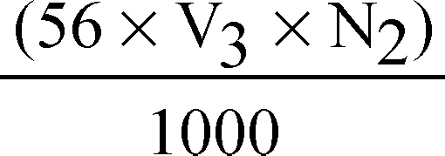V₃ mL N₂ N KMnO₄ of Fe = 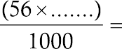 ………….(y) g of Fe
Step 2 10 mL of ore sample y g of Fe
250mL of ore sample 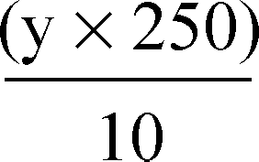= y ×25 g of Fe =…………..×25= (z)g Fe
Step 3 1 g of Sample (z)g Fe
100 g of sample =………… g of Fe

RESULTS AND/OR INTERPRETATION
Percentage of iron in haematite ore sample = %

CONCLUSIONS AND/OR VALIDATION

ASSIGNMENT QUESTION
1.Write chemical formula of potassium permanganate?
2.Write two ore of iron?
3.What happened when haematite is dissolved in HCl and H₂SO₄ solution?
4.Write two ionic form of iron?
5.Write chemicals required for this experiment?
6.Write apparatus required for this experiment?

EXPERIMENT NO:6
AIM OF THE EXPERIMENT: Estimate Iodometrically copper in the copper pyrite ore.

APPARATUS REQUIRED:
- Standard flask
- Funnel
- wash bottle
- beaker
- dropper
- spatula

CHEMICAL REQUIRED:
- Potassium dichromate(K₂Cr₂O₇)
- sodium thiosulphate(Na₂S₂O₃)
THEORY:
Due to ductility, electrical and thermal conductivity, copper is used in production of electrical conductors, switches, transformers and telecommunications. Hence its extraction and percentage calculations plays a vital role. Copper can be estimated through iodometric titration in which oxidizing agents liberates iodine which is titrated with standard solution of reducing agent called as indirect or back titration. In this titration iodine is liberated by oxidizing agent Cu2+, which is titrated against reducing agent sodium thiosulphate solution using starch as an indicator. The reaction between potassium iodide solution and potassium dichromate solution in acidic medium liberates iodine. Sodium thiosulphate solution (hypo solution) reduces liberated iodine to iodide
K₂Cr₂O₇+ 6KI + 14 HCl 2CrCl₃ + 8KCl +3I₂ + 7H₂O
Orange Green
Na₂S₂O₃+ 3I₂ 3Na₂S₄O₆ + 6NaI K₂Cr₂O₇ = 6Na₂S₂O₃
Oxidising agent K₂Cr₂O₇ Reducing agent Na₂S₂O₃ . 5H₂O
CuSO₄ + 4KI Cu₂I₂+ 2K₄SO₄ + I₂
Blue White ppt
Na₂S₂O₃ +I₂ Na₂S₄O₆ + 2NaI 2CuSO₄ 2Na₂S₂O₃
Oxidising agent Cu2+
Reducing agent Na₂S₂O₃ . 5H₂O

PROCEDURE:
Preparation of Standard Copper Sample (Brass solution / Test solution)
- Clean the glasswares thoroughly before use
- Weight 1 g of Copper sample, add to it 1:1 test solution of HNO₃ boil the mixture till brass dissolve completely.
- Add 1 g of urea to expel the dissolved NO₂ completely. Boil till white vapors appears.
- Add ammonia solution till deep blue colour appears.
- Add acetic acid till light blue colour appears. It is added to neutralize acid. For liberation of iodine, slight acidic environment is required.
- Transfer the reaction mixture in 250ml standard flask and dilute up to the mark.

Preparation of 250mL, 0.1N(0.1/6M) Potassium Dichromate Solution
Volume of Potassium dichromate solution (v) = 250mL Strength of potassium dichromate solution M= 0.1/6 M Molar Mass of potassium dichromate (K₂Cr₂O₇) =294 g mol–1
Weigh of K₂Cr₂O₇ for the preparation of 250mL 0.1/6 M solution
= =1.225g
- Weigh out accurately 1.225g of potassium dichromate using electronic balance.
- Transfer solid potassium dichromate in standard volumetric flask
- Add about 100mL of distilled water and dissolve solid potassium dichromate.
- Dilute the solution up to the mark i.e. to make it 250 ml

Preparation of 0.1 N Sodium Thiosulphate Solution
- Weigh out accurately 6.2 g of sodium thiosulphate
- Transfer sodium thiosulphate in another 250 ml standard flask
- Add about 100 ml of distilled water and dissolve solid sodium thiosulphate.
- Dilute the solution upto the mark i.e. to make it 250m

Procedure

Step 1: Standardization of Potassium Dichromate Solution
- Pipette out 20 ml of potassium dichromate solution into the conical flask.
- Add 10 ml of 20% KI solution in the conical flask which contains potassium dichromate solution.
- Add 5 ml of conc. HCl to same flask
- Close the conical flask with watch glass and put the conical flask in dark place for 5 min.
- Rinse and clean the burette with sodium thiosulphate solution (hypo solution)
- Place conical flask in the dark and add 150 ml of distilled water.
- Titrate this solution against sodium thiosulphate till it becomes pale yellow.
- Add 2 ml of starch as an indicator.
- Continue the titration till the solution becomes clear green.
- Note down the reading (end point of titration)

Step 2: Determination of Percentage of Copper
- Pipette out 20 ml of copper solution.
- Add few drops of ammonia solution in copper solution till it becomes turbid (forms ppt)
- Add few drops of acetic acid in copper solution till it dissolves all precipitate.
- Add 10mL of 20% KI solution
- Cover the conical flask with watch glass and put the conical flask in dark place for 5 min.
- Add 100 ml of distilled water
- Titrate this solution against sodium thiosulphate till it becomes pale yellow.
- Add 2 ml of starch to pale yellow solution (colour changes from pale yellow to dark blue/ violet ppt)
- Continue the titration with sodium thiosulphate till colour changes from dark blue to milky white solution
- Add 20 ml 2% of sodium thiocyanate solution
- Titrate this till it becomes white ppt.
- Note the end point of titration.

OBSERVATIONS AND CALCULATIONS
Observation Table 1: Standardization of Potassium Dichromate Solution
Readings Pilot Reading | 1 | 2 | 3 | Vx=Mean Difference  =(1+2+3)/3
Initial Burette Reading (IBR)
Final Burette Reading (FBR)
Difference (FBR-IBR)

1K₂Cr₂O₇ 6 Na₂S₂O₃ M₁= 0.1M, V₁= 20mL, n₁=1; M₂ = ? V₂= V_{x}, n₂= 6 M₁V₁ = M₂V₂ =
n₁ n₂

M₁ × V₁ × n₂
M2 = n₁ × n₂
= 0.1 × 20 × 6
6 × Burette reading V_{x}
= 2 =

6 × Burette reading V_{x}

Molarity of hypo solution = (Mhypo) = M
Observation Table 2: Determination of Percentage of Copper

Readings Pilot Reading | 1 | 2 | 3 | Vy=Mean Difference  =(1+2+3)/3
Initial Burette Reading (IBR)
Final Burette Reading (FBR)
Difference (FBR-IBR)
2Na₂S₂O₃ = 2CuSO₄
M₂= Mhypo, V₂= Constant burette reading (vy), n₂ = 2; M₃ = ? V₃= 20mL, n₃ = 2

M₂V₂
n₂
= M₃V₃
n₂

M2 × V2 × n2 = Mhypo × burette reading (Vy) × n₃

n₂ × n₃
n₂ × V₃
= Mhypo × burette reading (Vy) × 2 =
2 × 20

Molarity of copper Cu2+ solution = M₃ = M
Amount of Cu2+ in 100 mL solution = M₃ × Atomic weight of copper × 100
1000
M₃ × 63.5 × 100
=
1000 =
Amount of Cu2+ in 100 mL solution = z = M₃ ×6.35 1 g sample = z g Cu
100 g sample = z ×100 =………….. × 100 =…………..

RESULTS AND/OR INTERPRETATION
Percentage of copper present in given sample is = %

CONCLUSIONS AND/OR VALIDATION
…..……………………………………………………………………

ASSIGNMENT QUESTION

1.Write the chemical formula of potassium dichromate?
2.Write the chemical formula of sodium thiosulphate?
3.Write the chemical formula of copper sulphate?
4.Write the chemical formula of copper pyrite?
5.What happened when a few drops of ammonia solution added to a copper solution?
6.What is the colour of sodium thiosulphater solution ?
7.What is the colour of potassium dichromate?
8.Give examples of oxidizing agent and reducing agent?
9.Write the chemical formula of sodium thiocyanate ?

EXPERIMENT NO:7

AIM OF THE EXPERIMENT: Determine the Iron contents in given cement sample using colorimeter.

APPARATUS REQUIRED:

Standard volumetric flask (250Ml)

Beaker (100/250/500mL)

Burette

Pipette

CHEMICAL REQUIRED:

Cement sample

ferrous ammonium sulphate

40% potassium thiocyanate

40% ammonium thiocyanate

conc. H₂SO₄

dil HCl

KMnO₄
- HNO₃ sample and cement sample.

THEORY:
Colorimetry is the technique used to find the concentration of substance in coloured solution using instruments such as photo colorimeter or spectrophotometer.Principle behind this experiment is based on the Lambert Beer’s Law. The basis of spectrophotometric methods is the simple relationship between the absorption of radiation by the solution and the concentration of species in the solution. Whenever the monochromatic light (light of single wavelength) is passed into a coloured solution, some amount of the radiation is absorbed and remaining is transmitted. ‘I₀’ indicates intensity of incident radiation and ‘I’ indicates intensity of transmitted radiations. C is the concentration of solution and L is the path length of the cuvettes. When monochromatic light is passed through coloured solution the absorption takes place in the visible region. The absorption increases with the concentration, while transmission decreases due to increase in the concentration. When path length increases the absorption also increases.

PRACTICAL SETUP
(DRAWING/SKETCH/CIRCUIT DIAGRAM/WORK SITUATION)
The colorimeter consisting of a light source (lamp), filter, cuvette and photosensitive detector

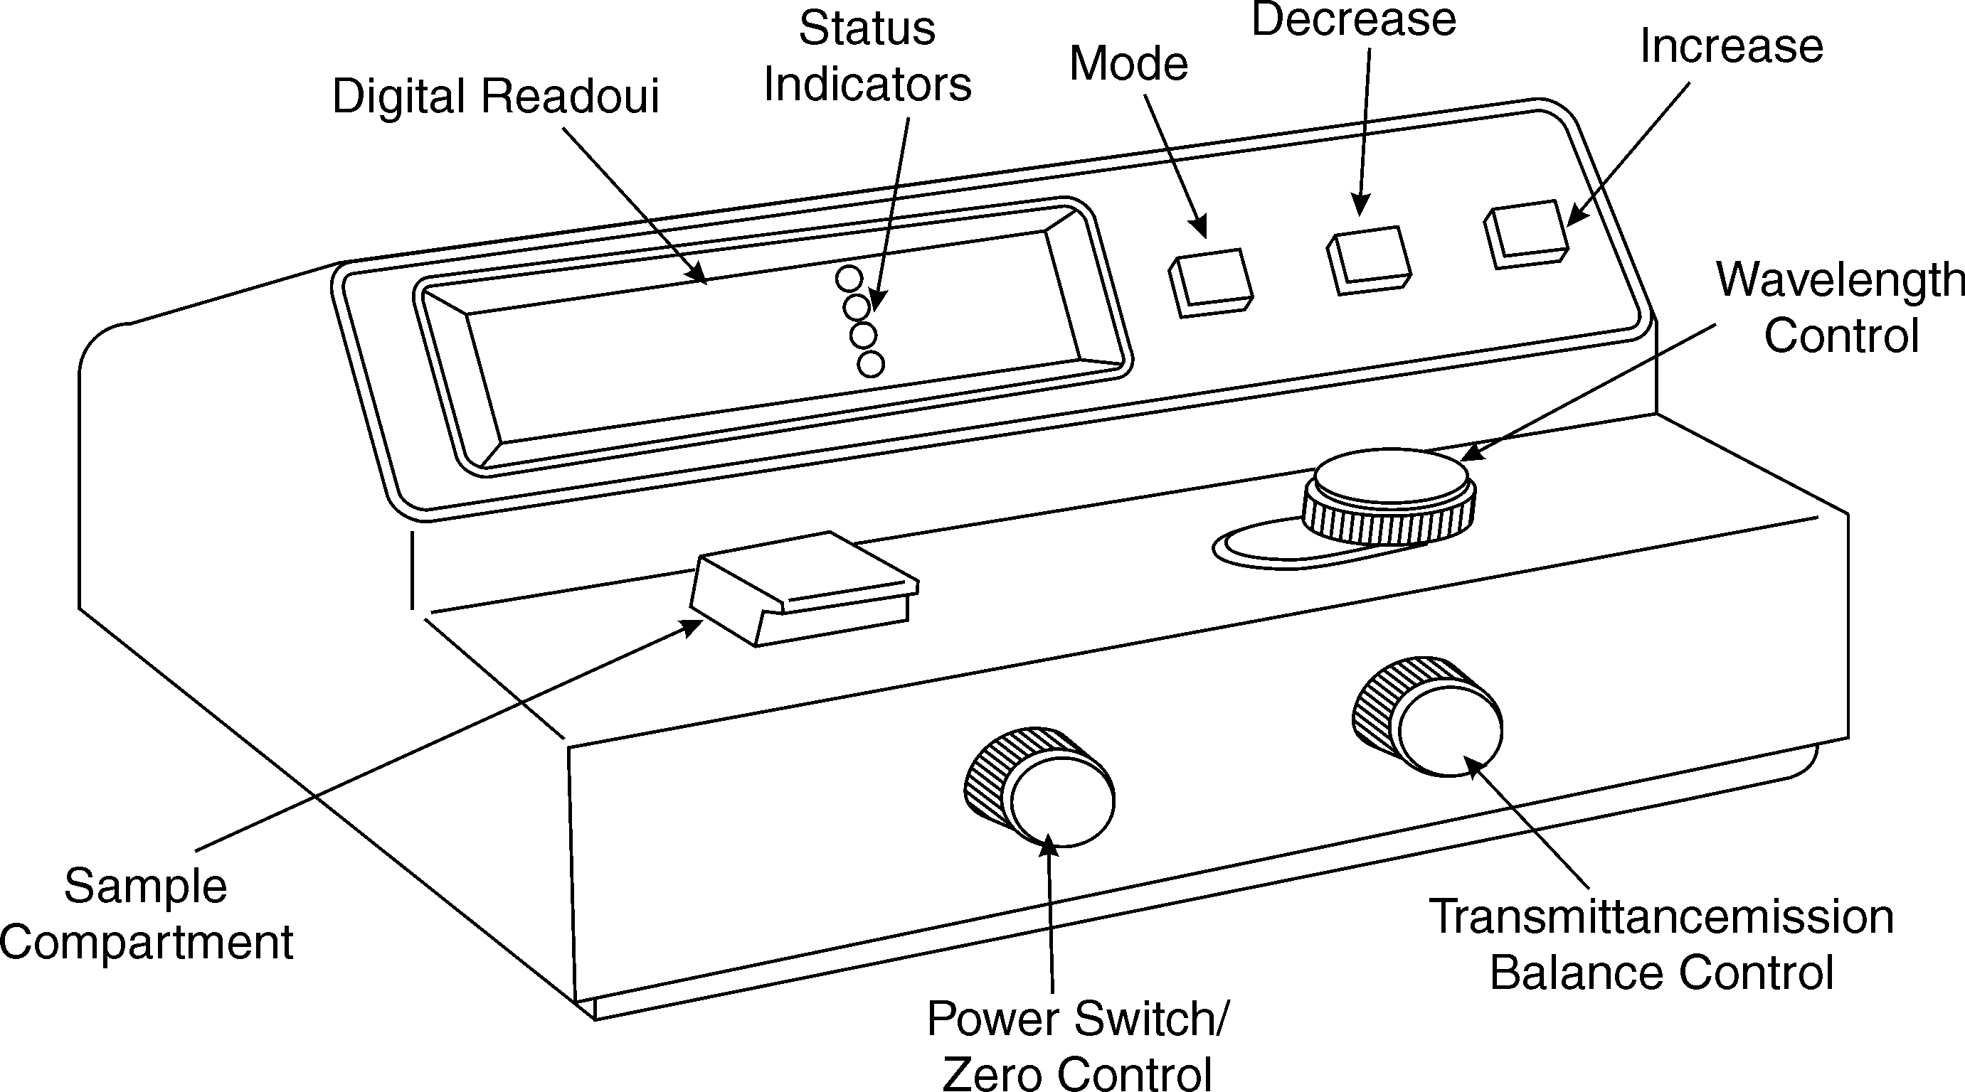to measure incident and transmitted light.. A colorimeter contains a photocell which is able to detect the amount of light passing through the solution under investigation. The current produced by the photocell depends on the quantity of light hitting it after passing through the coloured solution. The higher the concentration of the colorant in the solution, the higher is the absorption of light; less light passing through the solution means less current created by the photocell.
Transmission/ Absorbance
Balance Control

Fig. Key Operating Features of Colorimeter

PROCEDURE:

Preparation of Stock Solution
- Measure 0.083 g ferrous ammonium sulphate (FAS).
- Add 1mL conc. HNO₃ in FAS which converts Fe2+ to Fe3+
- Dilute the mixture using 1L of distilled water. This is the stock solution.
- Mix stock solution, ammonium thiocyanate (for development of colour) and distilled water as per observation table.

Procedure for Preparation of Cement Solution
- Weigh accurately about 0.1 g of the given cement sample into a clean 250 ml beaker.

- Add about 5 ml water to sample. Mix well and then add 1-2 mL concentrated HCl. Again mix well.
- Evaporate the mixture to dryness, expel the excess acid.
- Add 20 mL of distilled water to dissolve the contents and transfer all contents into standard volumetric flask (100 mL).
- Dilute the solution with distilled water up to the mark.
- Shake well for uniform concentration.
- Pipette out 10 ml of above solution, into 100 ml standard flask
- 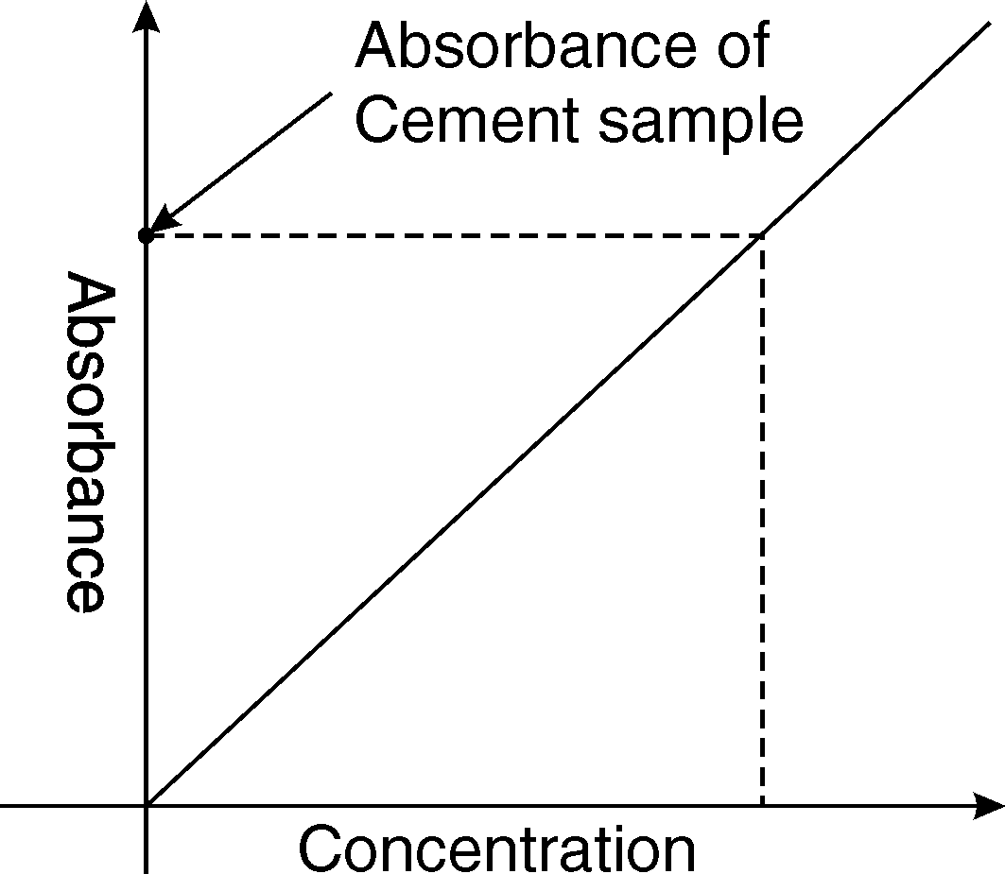Add 1 ml of conc. HNO₃ and then add 5 ml of 40% NH₄SCN with a burette. Make up the solution up to the mark with distilled water.

Procedure to Record Absorbance
- Blank solution with water and ammonium thiocyanate is mixed and kept in the cell. The absorption is measured for which absorption is zero and transmittance is 100
%.
- Now absorbance of all prepared standard solution is similarly measured in increasing order of concentration.
- Finally take the absorbance of the sample solution into colorimeter tube and measure the absorbance using the

photo colorimeter.
- Plot graph of absorbance (y-axis) vs concentration (x-axis).
- From the absorbance value we can measure the concentration of Fe2+ from the calibration curve.

OBSERVATIONS AND CALCULATIONS

Sr. No | Volume of FAS Stock Solution | Volume of Ammonium Thiocyanate | Volume of Distilled Water | Concentration of Fe3+ in ppm | Observed Absorbance
1 | 0 | 5 | 5 | ---
2 | 1 | 1 | 8 | 1
3 | 2 | 2 | 6 | 2
4 | 3 | 3 | 4 | 3
5 | 4 | 4 | 2 | 4
6 | 5 | 5 | 0 | 5
7 | Cement Solution
RESULTS AND/OR INTERPRETATION
1. Concentration of unknown cement sample from graph is = ..........................

CONCLUSIONS AND/OR VALIDATION
………………………………………………………

ASSIGNMENT QUESTION

1.Write the chemical formula of ferrous ammonium sulphate?

2.Write the chemical formula of potassium thiocyanate?
3.Write the chemical formula of ammonium thiocyanate?
4. What is the application of calorimetry?
5.What happened when monochromatic light passed through a colour solution?

EXPERIMENT NO:8

AIM OF THE EXPERIMENT: Determine the conductivity of given water sample.

APPARATUS REQUIRED:

1. Beaker (100ml)
2. Glass rod
3. Standard flask

Resources Conductivity meter (Range-0 to 20, 200 S accuracy 1% range) Magnetic stirrer (250-1250 rpm)

CHEMICAL REQUIRED:
1. 0.1N KCl solution
2. water sample

THEORY: Conductivity is the ability of a solution to conduct electric current. Conductivity is measured with a probe and meter. Conductivity (G) is inverse of resistivity (R) is determined from the voltage
and current values according to ohms law R=V/I then G=1/R=I/V. The meter converts the probe measurement to micro mhos per centimeter and displays the result.
Conductivity is measured in micro mho/cm(µmho/cm) or milli mho/cm (mmho/cm) or millisiemen/m (mS/m) 1mS/m=10 µmho/cm

PRACTICAL SETUP
(DRAWING/SKETCH/CIRCUIT DIAGRAM/WORK SITUATION)
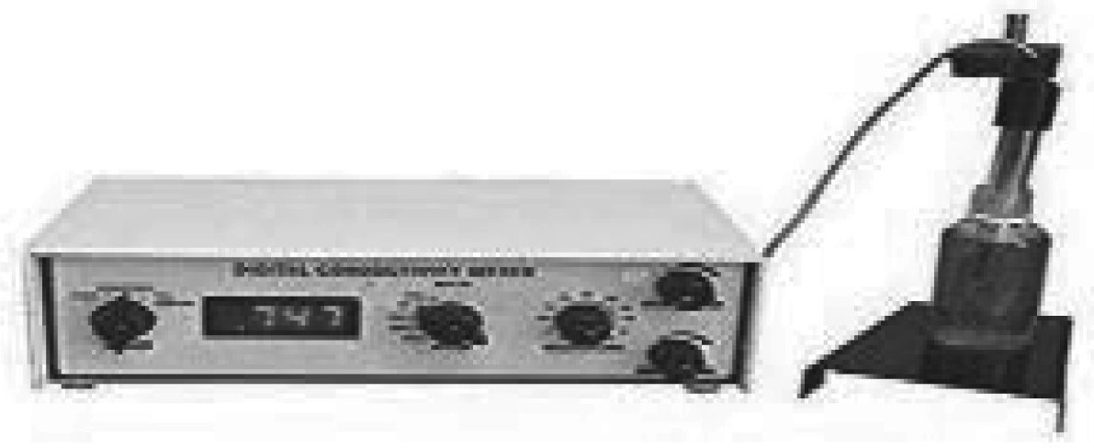

RESOURCES, CHEMICALS AND GLASSWARE REQUIRED
Resources Conductivity meter (Range-0 to 20, 200 S accuracy 1% range) Magnetic stirrer (250-1250 rpm)

PROCEDURE:
    - Measure 50 mL of distilled water and transfer it to the beaker.
    - Weigh 0.7456 g of Potassium chloride.
    - Transfer the 0.7456 g of potassium chloride to the beaker containing distilled water. Stir continuously by the glass rod until it dissolves thoroughly.
    - Transfer the contents to the 100 mL standard flask.
    - Make up the volume up to 100 mL. By adding distilled water and shake the contents well. The prepared solution is used to calibrate the conductivity meter.
Take 0.1N Potassium Chloride in a beaker. Switch on the magnetic stirrer and place the beaker on the stirrer. Insert the magnetic bead in the beaker.
Place the electrode inside the solution. Select the calibration button and by using up and down keys, adjust the conductivity of the 0.1N potassium chloride solution to 14.12 millisiemens /cm at 30°C.
    - Now the conductivity meter is ready for the measurement of samples.

Procedure for Testing of Water Sample
- Rinse the electrode thoroughly with deionised water and carefully wipe with a tissue paper
- Measure 200 mL of water sample and transfer it to a beaker and place it on the magnetic stirrer.
- Dip the electrode into the sample solution taken in a beaker and wait for a steady reading.
- Make sure that the instrument is giving stable reading.
- Note down the reading in the display directly, which is expressed in milli siemens.

OBSERVATIONS AND CALCULATIONS
Conductivity of given sample is milli siemens

RESULTS AND/OR INTERPRETATION
Conductivity of given sample is milli siemens
CONCLUSIONS AND/OR VALIDATION

CONCLUSIONS AND/OR VALIDATION

EXPERIMENT NO:9

AIM OF THE EXPERIMENT: Verify the Faraday’s first law of electrolysis of copper sulphate solution using copper electrode.
APPARATUS REQUIRED:
1. Beaker (1000mL)
Resources :Cu plates, iron spoon, ammeter, rheostat, plug key, battery (12 volts), connecting wires, stopwatch, polish paper, air drier, electronic balance.
CHEMICAL REQUIRED:
- Copper sulphate (CuSO₄)
- 1% H₂SO₄
THEORY:
The first law of electrolysis state that the amount of chemical change produced by current at an electrode-electrolyte boundary is proportional to the quantity of electricity used. The amount of chemical change produced by the same quantity of electricity in different substances are
proportional to their equivalent weights. The weight of substance deposited or liberated at an electrode is directly proportional to the quantity of electricity passed through the electrolytes.

PROCEDURE
- Weigh the iron spoon, before mounting the electrode as W1.
- Setup the apparatus and connect the circuit as indicated in the figure
- Adjust the required current between 1 to 2 ampere with the help of ammeter and rheostat simultaneously. Start the stopwatch.
- Pass the current for 900 sec(15 min) using stopwatch
- After 15 min remove iron spoon. Dry it with air drier and weigh accurately as W2

OBSERVATIONS AND CALCULATIONS

Sr. No. | Observations | Value
1 | Weight of iron spoon (Cathode) before deposition (W1) | ……………………g
2 | Weight of iron spoon after deposition (W2) | ……………………g
3 | Weight of copper deposited  W= W2-W1 | ……………………g
4 | Current in ampere(actual passed) | ………………….ampere
5 | Time in seconds | ………………….sec
Faraday’s First Law of electrolysis W= ZIt
Z = =  =

RESULTS AND/OR INTERPRETATION
1. Electrochemical equivalent of copper = g/C

CONCLUSIONS AND/OR VALIDATION

EXPERIMENT NO:10
AIM OF THE EXPERIMENT: Determine the emf using an electrochemical cell .(Daniel Cell)

APPARATUS REQUIRED:
1. Beaker (1000mL)
Resources :Multimeter, voltmeter, connecting wires
CHEMICAL REQUIRED:
1. CuSO₄
2. ZnSO₄
3. Zn Rod
4. Cu Rod
5. Salt bridge
THEORY:
The potential difference between the two electrodes in a galvanic cell is called a cell potential or emf of the cell. It is measured in volts.Daniel cell is also known as a galvanic cell or voltaic cell. This cell is an example of an electrochemical cell. Generally, rods or plates are termed as electrodes. Each electrode is immersed in its metal salt solution, and these forms half-cell. Two half-cells are separated by a salt bridge or porous partition. The solution which conducts electricity either in a molten state or in an aqueous solution is called electrolytes. One electrode acts as an anode where oxidation takes place. When two metals are connected, the metal with higher activity acts as an anode while the other metal acts as the cathode.
Electrode reactions in daniel cell

Reaction at anode Zn Zn2+ + 2e– Oxidation Reaction

Reaction at cathode Cu2+ + 2e– Cu Reduction Reaction
Zn + Cu2+ Zn2+ + Cu Redox Reaction
Daniel cell is represented as Zn(s) | ZnSO₄ (aq)|| CuSO₄ _{(aq)} | Cu(s)
Voltage produced at daniel cell is the sum of reduction and oxidation voltage developed across the electrode is written as E0Cell = E0Reduction + E0Oxidation

PRACTICAL SETUP
(DRAWING/SKETCH/CIRCUIT DIAGRAM/WORK SITUATION)
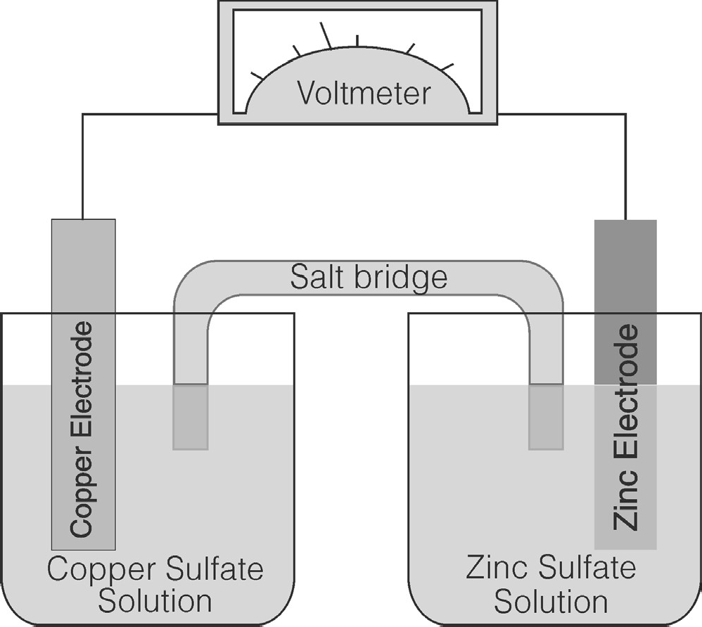A primary cell with a constant electromotive force of about 1.1 volts having as its electrodes copper in a copper sulfate solution and zinc in dilute sulfuric acid or zinc sulfate, the two solutions being separated by a porous partition. In Daniel cell Cu and Zn electrodes are immersed in CuSO₄ and ZnSO₄ solution respectively. Zn acts as anode and Cu acts as cathode. Oxidation takes place at Zn and reduction takes place at the cathode. The Zn ions passed in solution. As two electrodes are connected using an external wire, the electrons produced by oxidation of Zn move through the wire and are collected at the copper electrode. Cupric ions present in the solution (electrolyte) accept electrons and are discharged at the cathode.
Zinc Sulphate
Solution
Copper
Sulphate Solution

PROCEDURE
- Place Zn rod in ZnSO₄ solution and Cu in CuSO4 solution.
- Connect Zn rod to one end and Cu rod to another end of the multimeter.
- Place salt bridge in both the solution. A Salt bridge is an inverted ‘U’ tube filled with the saturated solution of an inert electrolyte KCl/KNO₃ containing agar-agar, it releases ions into the electrolyte so that the whole solution becomes electrically neutral.
- Take the concentration of ZnSO₄ and CuSO₄ solution as shown in observation table.
- Prepare five different concentrations of ZnSO₄ and CuSO₄, respectively.
- Connect two beakers with combinations shown in the observation table.
7.Record the emf developed across these two half cell
.

OBSERVATIONS AND CALCULATIONS

Cell No. | Concentration of ZnSO₄ | Concentration of CuSO₄ | EMF produced (in Volts)
1 | 2Molar (M) | 2M
2 | 1M | 2M
3 | 0.5M | 2M
4 | 0.25M | 2M
5 | 0.0125M | 2M
6 | 2M | 1M
7 | 2M | 0.5M
8 | 2M | 0.25M
9 | 2M | 0.0125M
RESULTS AND/OR INTERPRETATION
- Emf developed in cell 1 is = Volts
- Emf developed in cell 2 is = Volts
- Emf developed in cell 3 is = Volts
- Emf developed in cell 4 is = Volts
- Emf developed in cell 5 is = Volts
- Emf developed in cell 6 is = Volts
- Emf developed in cell 7 is = Volts
- Emf developed in cell 8 is = Volts
- Emf developed in cell 9 is = Volts
- Emf developed in cell 10 is = Volts

CONCLUSIONS AND/OR VALIDATION

EXPERIMENT NO:11

AIM OF THE EXPERIMENT: Determine the effect of connection of two dissimilar metals immersed in solution.

APPARATUS REQUIRED:
- Beaker (1000mL)
- Salt bridge (U tube containing KCl or KNO₃ with agar-agar)
CHEMICAL REQUIRED:
- CuSO₄(2M)
- ZnSO₄(2M)
- Al₂(SO₄)₃(2M)
- Zn rod
- Cu rod Al rod
THEORY: In electrochemical series , metals are arranged according to their standard electrode potential. The active metals are at the top, while less reactive or noble metals are at the bottom. Elements at a higher position in the series have a greater tendency to lose electrons. Such metals are readily oxidized. Elements at a lower position in series do not lose electrons. When two dissimilar metals are connected, the metal with a higher position in the activity series acts as anode and gets corroded, while the metal with a lower position in the activity series acts as the cathode and gets protected. When dissimilar metals contact with each other in the presence of moisture, galvanic corrosion may result. The wet metals behave like a battery and produce an electrical current. The surfaces of one or both metals become pitted and corrode, as the exchange of electrons takes place. Metal machinery can be protected by attaching a more active metal , through process called cathodic protection.

Resources : Voltmeter, connecting wires, electronic balance

PRACTICAL SETUP
(DRAWING/SKETCH/CIRCUIT DIAGRAM/WORK SITUATION)

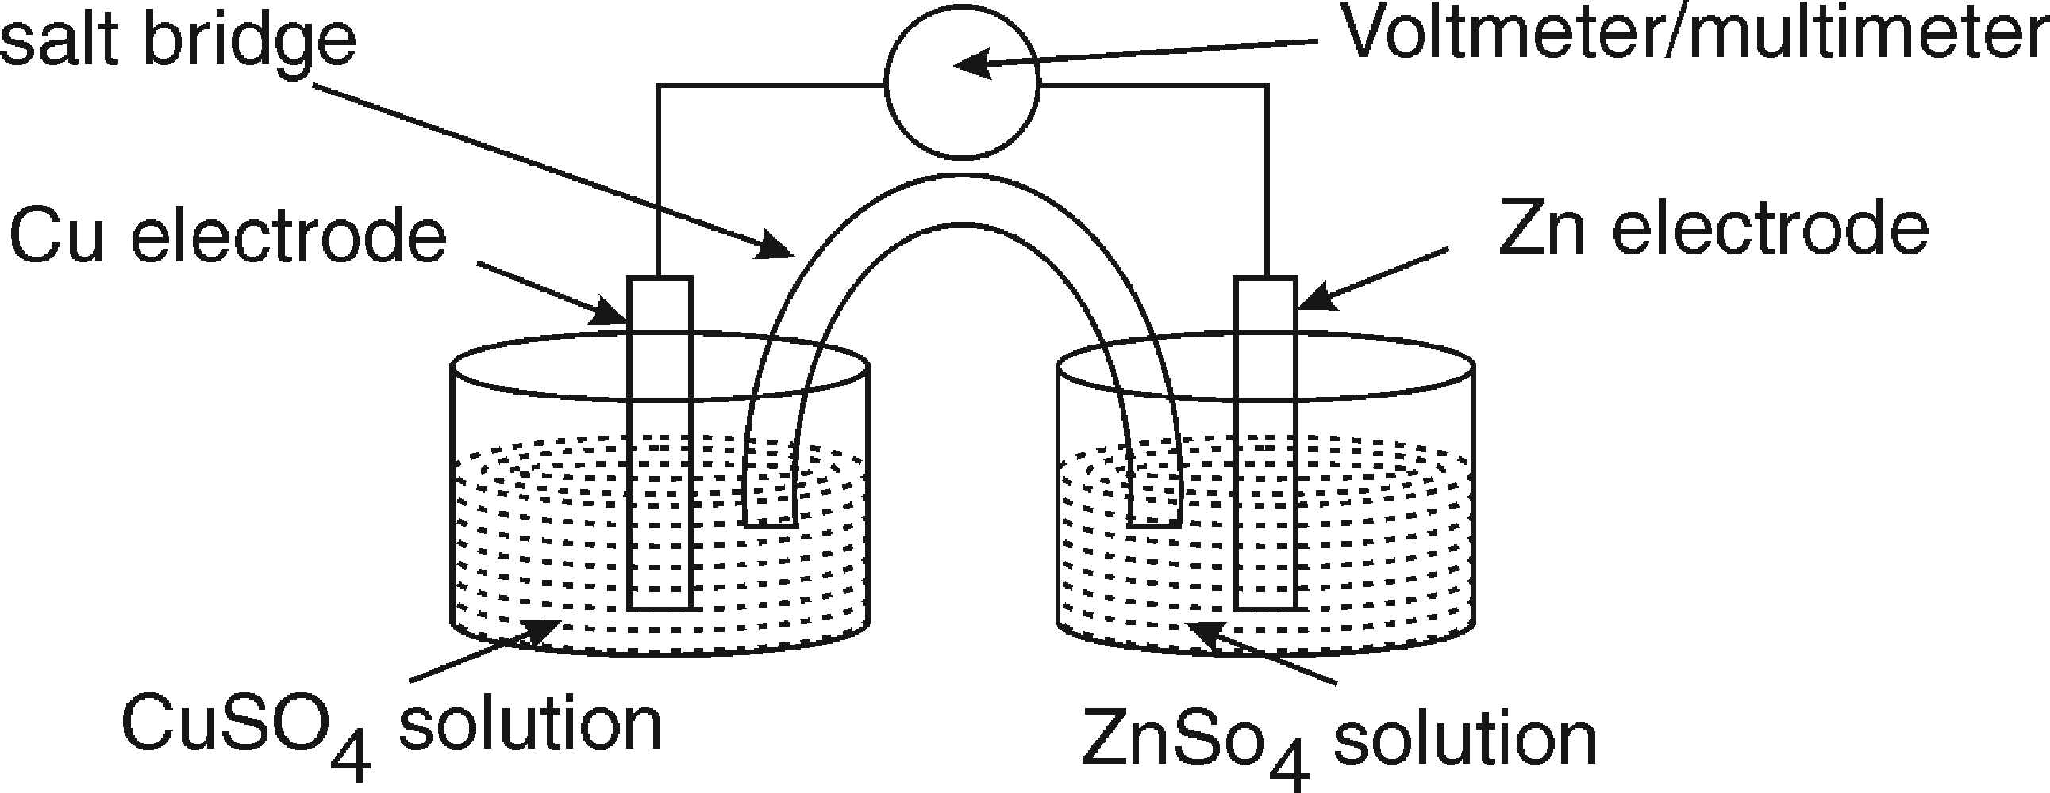
Salt Bridge
Voltmeter/Multimeter
Cu Electrode
Zn Electrode
CuSO₄ Solution
ZnSO₄ Solution

PROCEDURE
Setup 1 (Cu-Zn cell)
- Weight copper and zinc rod.
- Take zinc sulphate solution in one beaker and copper sulphate in another.
- Immerse zinc rod as an electrode in zinc sulphate solution and copper rod as an electrode in copper sulphate solution.
- Connect zinc rod to the negative terminal of the voltmeter and copper rod to the positive terminal of the voltmeter.
- After 30 minutes, disconnect the cell, remove the electrodes and dry them with an air drier.
- Weigh the zinc and copper electrodes.

Setup 2 (Zn-Al Cell)
- Weight aluminium and zinc rod.
- Take zinc sulphate solution in one beaker and aluminium sulphate in another.
- Immerse zinc rod as an electrode in zinc sulphate solution and aluminium rod as an electrode in aluminium sulphate solution.
- Connect aluminium rod to the negative terminal of the voltmeter and zinc rod to the positive terminal of the voltmeter.
- After 30 minutes, disconnect the cell, remove the electrodes and dry them with an air drier.
- Weight the zinc and aluminium electrodes.

OBSERVATIONS AND CALCULATIONS
Setup I (Cu-Zn cell)
- Weight of copper W1 Cu before starting experiment = g
- Weight of zinc W1 Zn before starting experiment = g

- Weight of copper W2 Cu after 30 minutes = g
- Weight of zinc W2 Zn after 30 minutes = g
- Change in Weight of Cu Rod = g
- Change in Weight of Zn Rod = g

Setup II (Zn-Al Cell)
- Weight of aluminium W1 Al before attachment = g
- Weight of zinc W1 Zn before attachment = g
- Weight of aluminium W2 Al after 30 minutes = g
- Weight of zinc W2 Zn after 30 minutes = g
- Change in Weight of Al Rod = g
- Change in Weight of Zn Rod = g

RESULTS AND/OR INTERPRETATION
- The weight of Zn metal decreases when it is attached with metal. Hence zinc
get corroded when attached with metal.
- The weight of Zn metal increases when it is attached with metal. Hence zinc get
protected when attached with metal.

CONCLUSIONS AND/OR VALIDATION

EXPERIMENT NO:12

AIM OF THE EXPERIMENT: Determine total acid number (TAN) of given oil.

APPARATUS REQUIRED:

1. Conical flask (100 ml)
2. Burette (50 ml)
3. pipette (10 ml)
4. weighing balance (0.0001 mg sensitivity)

CHEMICAL REQUIRED:
1. Oil sample
2. phenolphthalein indicator
3. KOH

THEORY: TAN is determined by titrating a sample with potassium hydroxide (KOH) solution and measuring the potential. The TAN is calculated based on the titrant consumption at the last equivalence point and a calibration with potassium hydrogen phthalate.

PROCEDURE
- Weight 1g of oil sample in conical flask.
- Add 50ml of ethyl alcohol to oil to shake the solution to dissolve oil completely.
- Add 2-3 drops of phenolphthalein indicator into the solution in conical flask.
- Rinse and fill the burette with 0.01 N KOH solution
- Titrate the solution in conical flask with 0.01 N KOH solution till colour changes from colourless to permanent light pink
- Repeat the procedure for three consecutive burette readings.

OBSERVATIONS AND CALCULATIONS

1. Solution in burette ………………….......................
2. Solution in conical flask ……………….............…..
3. Indicator ………………….....................................
4. End Point ………….................................………..

Observation Table

Readings | Pilot Reading | 1 | 2 | 3 | Mean Difference  =(1+2+3)/3
Initial Burette Reading (IBR)
Final Burette Reading (FBR)
Difference (FBR-IBR)

CALCULATIONS: 1000 ml of 1N KOH = 56.119 g of KOH
1 ml of 1N KOH = 5 6.119 mg of KOH
1 ml of 0.01 N KOH = 56.119 × 0.01 mg of KOH
(mean difference) ml of 0.01 N KOH = 56.119 × 0.01 × (mean difference ml) mg of KOH Acid value of oil sample= 56.119×0.01×(mean difference mL) milligram of KOH /1g of Oil
= ................................................
Acid Value = .

RESULTS AND/OR INTERPRETATION
Acid Value of 1g of given sample of oil is ……………………………

CONCLUSIONS AND/OR VALIDATION
…..………………………………………………………………
EXPERIMENT NO:13
AIM OF THE EXPERIMENT: Estimate gravimetrically the moisture and ash contents in the given coal sample (Proximate Analysis).

APPARATUS REQUIRED:
- Electric balance
- electric furnace
- muffle furnace
- pair of tongs
- silica crucible

CHEMICAL REQUIRED:
- coal sample

THEORY : Moisture, volatile matter, ash and fixed carbon are the main parameters to be determined for the estimating the quality of the solid fuel material such as coal coke. Moisture content is an important parameter in coal analysis. It is needed for determining the calorific (heating) value and handling properties of a coal. The ash yield provides information on how much material will be left after combustion, which will need to be disposed off. In the steel industry, low-ash contents are preferred for coking coals. Proximate analysis covers the determination of moisture, volatile matter, fixed
carbon, and ash in coals and cokes, and is used to establish the rank of coals, to show the ratio of combustible to incombustible constituents, or to provide the basis for buying/selling, and otherwise evaluating coal for various purpose

PROCEDURE
Part A : Process of Determining the Moisture.
- Weigh approximately 1 g of air dried coal sample in silica crucible.
- Place the crucible in electric oven maintained at 1050C for 1 hour
- Find the difference between starting weight and the final weight of coal sample which represents the amount of moisture as the moisture is evaporated during heating.

Part B : Process of Determining the Ash.
- Weigh exactly moisture free (from part A) coal sample in silica crucible.
- Place the crucible in muffle furnace maintained at 750°C for 1 hour.
- Find the weight of ash formed.

OBSERVATIONS AND CALCULATIONS
Part A: Determination of Moisture Content
- Weight of empty crucible = W₁ = g
- Weight of crucible and coal sample before heating = W₂ = g
- Weight of coal taken =W₃ = W₂–W₁ = g
- Weight of silica crucible and coal sample after heating = W₄ = g
- Weight of moisture removed W₅ = W₂– W₄ = g
% of moisture content = 100
=  × 100

Part B : Determination of Ash Content
- Weight of empty crucible = W1 = g
- Weight of silica crucible and coal sample before burning = W2 = g
- Weight of coal taken =W3 = W2 - W1 = g
- Weight of silica crucible and ash = W4 = g
- Weight of ash formed W5 = W4 - W1 = g

% of ash content =  × 100
=  × 100

RESULTS AND/OR INTERPRETATION
- Percentage of moisture contents in coal = %
- Percentage of ash contents in coal = %

CONCLUSIONS AND/OR VALIDATION

EXPERIMENT NO:14
AIM OF THE EXPERIMENT: Determine the calorific value of solid or liquid fuel using bomb calorimeter

APPARATUS REQUIRED:
1. Electronic balance (0.0001mg sensitivity)
2. electric oven ( size-18” × 18” × 18” ) 40 litre capacity temperature up to 2500C
3. standard bomb calorimeter
4. pair of tongs
5. silica crucible
CHEMICAL REQUIRED:
1. coal sample

THEORY:
The calorific value is the most important property of fuel. It may be defined as the total quantity of heat liberated by the complete combustion of a unit mass of the fuel. The calorific value determines the quality of fuel and also helps in calculating thermal efficiency and heat balance in the process where coal is used as a fuel. The Higher Calorific Value (HCV) or Gross Calorific Value (GCV) is obtained when water formed by combustion is completely condensed. The Lower Calorific Value (LCV) or Net Calorific Value (NCV) is obtained when the water formed by combustion exists completely in the vapour phase. Basically, this device burns a fuel sample and transfers the heat into a known mass of water. Basically, bomb calorimeter burns a fuel sample and transfers the heat into a known mass of water.

PRACTICAL SETUP
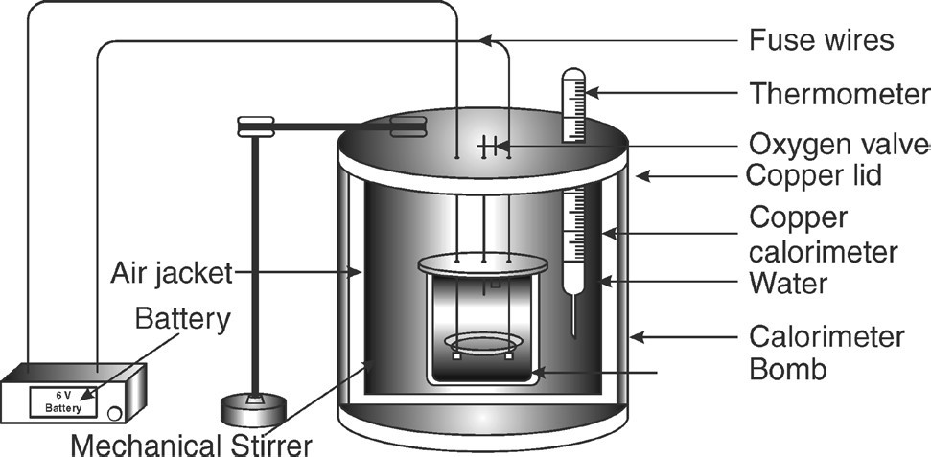(DRAWING/SKETCH/CIRCUIT DIAGRAM/WORK SITUATION)
Bomb calorimeter
The bomb calorimeter consists of a strong steel shell known as a bomb. It consists of a base which supports the platinum crucible and is screwed to the body of the bomb. The top of the bomb carries an oxygen supply connection and a valve to release the product. The electrodes extend through the base of the bomb and connect the fuse wire to an electric circuit. The coal can be ignited by closing the electric circuit. The bomb is placed inside a copper vessel which contains water. There is a stirring device for agitating the water within the calorimeter. The calorimeter containing the bomb is placed in another container which acts as a heat insulator. The temperature of water in the calorimeter is measured by a thermometer.

PROCEDURE
- Take about 1 g of solid fuel sample in a silica crucible introduce it into the bomb calorimeter
- Add the 2000 mL of distilled water, start the stirrer and note down the initial temperature of water.
- Pass the oxygen gas at about 20 to 25 atm.
- Start current through the crucible and let the fuel sample to burn in presence of oxygen.
- The fuel is burnt by producing electric spark inside the bomb calorimeter.
- Heat released during combustion of sample fuel is taken by water, due to which temperature of water increases.
- Record the final constant temperature.
- Water equivalent of calorimeter is determined by repeating the same procedure using benzoic acid which is the standard fuel of known GCV.

OBSERVATIONS AND CALCULATIONS

Sr. No | Description | Weight in grams
1 | Water equivalent of bomb calorimeter = fixed for calorimeter or can be calculated by burning benzoic acid=(m1)
2 | Mass of water in copper calorimeter (m2)
3 | Specific heat of water (Cw)
4 | Weight of solid fuel coal sample taken Ws
5 | Initial temperature of water (t1)
6 | Final temperature of water (t2)
Calculations
Heat liberated by Ws kg of fuel in vessel = Heat absorbed by (m1+m2) kg of water in bomb
……(1)
We know that heat liberated by 1kg of fuel in closed apparatus = GCV
Heat liberated by Ws kg of fuel in closed apparatus = GCV × Ws (2)
Heat absorbed by 1kg of water to raise its temperature by 100C = specific heat of water
=4.187 kJ/ kg/0C Heat absorbed by (m1 + m2) kg of water to raise its temperature
From t1 to t20C=(m1+m2) × (t2 – t1) ×Cw (3)
Substituting equation 2 and 3 in equation 1 GCV × Ws =(m1+m2) × (t2 – t1) × Cw
Gross Calorific Value (GCV) = 
= 
Calorific value = Cal/g
Calorific value = ……………………..× 4.183 ×103 J/kg = J/Kg

RESULTS AND/OR INTERPRETATION
Calorific value of sample fuel is ……………………

CONCLUSIONS AND/OR VALIDATION

EXPERIMENT NO:15
AIM OF THE EXPERIMENT: Determine the viscosity of lubricating oil using Redwood viscometer

APPARATUS REQUIRED:
- Kohlrausch flask (50 mL- flask with marking upto 50mL)
- measuring cylinder [100 mL]
- Redwood viscometer No1(standard)
- stop watch
- Thermometers

CHEMICAL REQUIRED:
- Lubricating oil (60 mL)

THEORY: Viscosity or the thickness of the oil is important because it determines the lubricant’s film strength and efficiency in preventing friction between moving parts. If a lubricant is too thin, the film may not be thick enough to prevent friction.
Use of the correct viscosity lubricant for the speed, temperature and loads ensures the development of a full oil film between rotating parts. The optimum fluid film is sufficiently thick to allow the rolling elements to function without metal-to-metal contact with minimum friction.

PRACTICAL SETUP
(DRAWING/SKETCH/CIRCUIT DIAGRAM/WORK SITUATION)
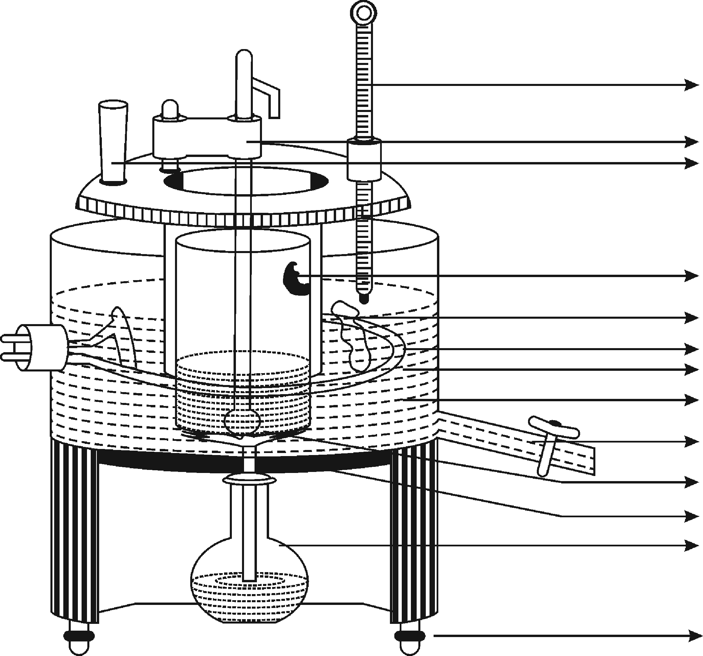
Fig. Redwood Viscometer
Oil Level
Stirrer Heating Coil Heating Bath
Oil Cup
Water Outlet Valve Rod Agate Jet
Kohlrausch Flask

Leveling Screws
Thermometer

Holder Cup Stirrer Handle

Viscosity of lubricating oil is measured with the help of viscometer. In a viscometer fixed volume of the liquid is allowed to flow from a given height, through a standard capillary tube under its own weight and the time, of flow in seconds is noted. The time in seconds is proportional to true viscosity. Redwood viscometer is used to measure viscosity of lubricant oil. It is of two types. Redwood viscometer No 1 is used to measure viscosity of low viscous lubricant oil. It has jet of bore diameter 1.62 mm and length 10 mm. Redwood viscometer No 2 is used to measure viscosity of highly viscous lubricant oil. It has a jet of diameter 3.8 mm and length 15 mm

PROCEDURE
- Fill the water in water bath, to the height corresponding to the tip of indicator up to which the oil is filled in the cylindrical cup.
- Keep the brass ball of valve rod in position so as to seal the orifice.
- Pour the oil under test carefully into the oil cup upto the tip of the indicator.
- Weigh empty Kohlrausch flask or empty measuring cylinder as W1.
- Keep an empty 50mL Kohlrausch flask (or measuring cylinder) in position below the jet.
- Place the thermometers, one in oil and other in water.
- Keep the oil and water well stirred and note their temperatures.
- When the temperature of oil and water are steady at 60°C, raise the ball valve and suspend it from the thermometer bucket and simultaneously start the stop watch.
- When level of oil dropping into the Kohlrausch flask reaches to the 50mL mark, stop the stop watch and note the time in seconds, called as time of efflux.
- Weigh the flask with 50mL oil record as W2
- Replace the ball value in position to seal the cup to prevent overflow the oil.
- Refill the oil up to the indicator tip of the oil cup.
- Record the time required to efflux the oil for different temperatures say 50°C and 40°C.
- Record the time of efflux as explained above.
- Plot graph between viscosity (y-axis) vs temperature (x-axis).

OBSERVATIONS
Weight of empty kohlrausch flask =W1 g = g
Weight of flask + 50mL oil =W2 g = g
Weight of oil =W= W2-W1 = g
Density of oil == = =………..g/m3=…………×1000 = Kg/m3

3 Specific gravity of oil ‘S’== 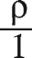= =

Sr.  No. | Temp°C | Time for Collecting of 50mL  Oil (R) (Sec) | Weight of Oil W (g) | Density of Oil (Kg/m3) | Specific Gravity of oil (s) | Redwood Number RN (Sec) | Kinematic Viscosity ( = in m2/s) | Absolute Viscosity ( = ×  in Ns/m2)
1 | 60
2 | 50
3 | 40


Redwood Number (RN) == = Where
K is constant =100, R= time for collecting 50mL of oil, S- specific gravity of oil, R1 is constant =535,
s1 is specific gravity constant of oil = 0.915

If RN is below 100, use formula as follows
Kinematic viscosity V = 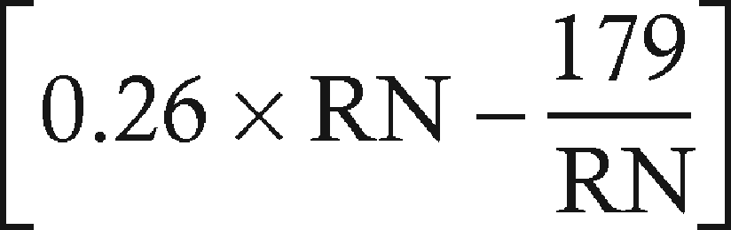 ×10–6 m2/s
If RN formula is above 100 then use formula as = V × in
Kinematic viscosity V =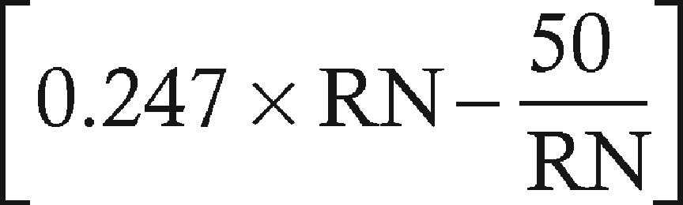 ×10–6 m2/s Dynamitic viscosity or Absolute viscosity

RESULTS AND/OR INTERPRETATION
- Viscosity of given lubricating oil at room temperature………………………………
- From graph as temperature increases viscosity of given oil……………………..

CONCLUSIONS AND/OR VALIDATION

EXPERIMENT NO:16
AIM OF THE EXPERIMENT: Determine the flash and fire point of lubricating oil using Abel’s flash point apparatus

APPARATUS REQUIRED:
- Abel’s standard apparatus
- spirit lamp
- water bath
- lubricating oil

THEORY
Flash point is the lowest temperature at which a liquid can gives off vapour to form an ignitable mixture in air near the surface of the liquid or ignition of a substance initiates. The fire point describes the lowest temperature at which the fuel continues to burn for a short time period after the initiation of the ignition. The fire point is usually a few degrees above the flash point.

PRACTICAL SETUP
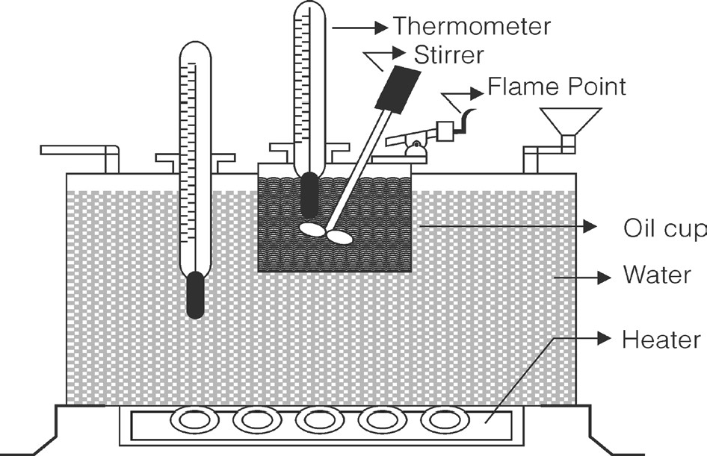(DRAWING/SKETCH/CIRCUIT DIAGRAM/WORK SITUATION)
Fig. Abel’s Apparatus
Abel’s apparatus consists of cylinder brass cup surrounded by a double jacketed copper water bath which is enclosed in a copper casing mounted on an iron tripod. The oil cup is provided with a
brass cover having arrangement for small test flame, a sliding shutter covering three small opening in the lid and opening for a paddle stirrer and the standard thermometer, the bulb of which should be immersed in the oil.

PROCEDURE
- Fill the cup with oil under the test upto the point of gauge and place the cover.
- Fix the oil cup into the apparatus and assemble the paddle stirrer and standard thermometer with its bulb dipping into oil at their respective places provided in the apparatus.
- Fill the water bath with cold water.
- Close the sliding shutter and light the standard flame.
- Switch on the heating arrangement.
- At every degree rise of oil temperature, upon the sliding shutter. Introduce the flame over the oil surface through the central opening to see whether the oil gives flash and fire . Record the minimum temperature at which a distinct flash appears as the flash point of oil.
- Increase the temperature again gradually up to fire point so that lubricant vapors can burn continuously more than 5 sec.
- After getting the fire point remove the oil cup from apparatus for cooling.
- During cooling verify the observed readings.

RESULTS AND/OR INTERPRETATION
- Selected Lubricant oil gives flash point at ………°C
- Selected Lubricant oil gives fire point at °C

CONCLUSIONS AND/OR VALIDATION

